Design Report – March 14, 2016

Philadelphia Flower Show Entries

Tala Graham – Miniature Arrangement ‘Spirit World’

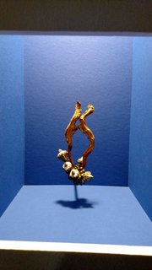

Awards: Class Commendation Ribbon (All class entries scored 90 or higher) and a Yellow Ribbon

Judges’ Comments: INTRIGUING SELECTION OF TEXTURES AND PATTERNS. CONCENTRATION OF PLANT MATERIAL AT BASE OF DESIGN CREATES WEIGHTINESS.

Diane Mateson – Miniature: ‘Let Freedom Ring’
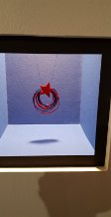
Awards: Class Commendation Ribbon and a Yellow Ribbon
Judges’ Comments: PATRIOTIC GLOSSY COLORS RING TRUE.
LACK OF DEPTH INHIBITS THE RHYTHM OF THE DESIGN.

Kris Qualls – Miniature Arrangement ‘Shape Shifter’
This was a Component Challenge Class. Kris used natural objects she had received from PHS to create her design.
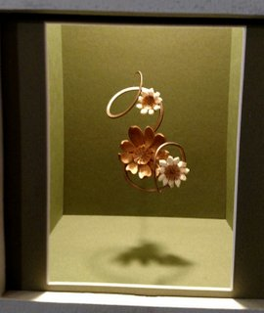
Awards: Class Commendation Ribbon and a Red Ribbon
Judges’ Comments: STRONG WELL BALANCED DESIGN.
RHYTHM INTERRUPTED BY PLACEMENT OF CENTRAL FLOWERS.
Bev Schmitt – Pedestal: ‘Natural Beauty – Big Bend’

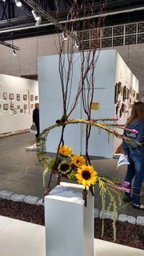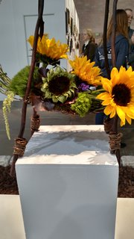

Awards: Honorable Mention Ribbon
Judges’ Comments: ATTRACTIVE COMBINATION OF COLOR – TEXTURE.
VERTICAL ELEMENTS OVERWHELM.

Note: A close-up of the base of the design allows you to zero in on the innovative use of ‘feet’ on the pedestal to support the design. A standard container became unnecessary.

Balcony – ‘Garden with a View’
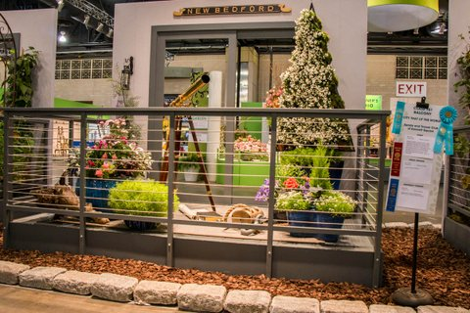
Friday’s Judging: Red Ribbon
Judges’ Comments: CLEAN ELEGANT DESIGN
Note: Since we are allowed to tweak our design before the 2nd judging, we wanted to know where points were lost. From the ‘Master Comment Sheet, we learned the following:
- Under ‘Design Concept & Execution’ we lost two points. Comment said ‘Design sparse. Color Scheme suggests blue and white.’
- Under ‘Educational value to the Public’ we lost two points. Comment said, ‘Not obvious educational—more inspirational.’
To address the judges’ comments, we made the following changes:
- Plants in one pot were changed to give additional color. Pink begonias and purple ‘Magic Mee’ campanulas were used.
- The lantern that had been on the floor was hung to the left of the doorway, adding weight to the left side.
- A nautical map of Buzzards Bay and an old copy of ‘Moby Dick’ were place beneath the telescope.
Wednesday’s Judging: Blue Ribbon and Class Commendation – also by virtue of total points earned on the two judging’s, the ‘Best of the Blues’ Ribbon
Judges’ Comments: CONDITION OF PLANTS IMPECCABLE.
BEAUTIFULLY STAGED. STRIKING COLOR.

On Friday Spade and Trowel’s exhibit won the Maintenance Award.

