January 2016 Design Report
Floating Hellebores

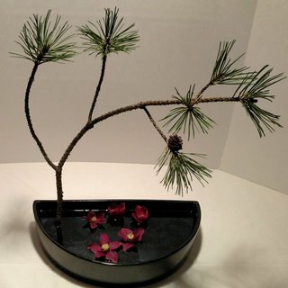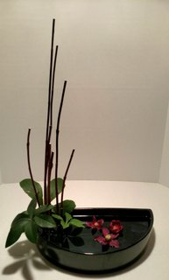

At this time of the year, finding garden materials to bring into our homes becomes problematic. So, my first thought was to repurpose branch materials that I had used during the Christmas season.
In the 1st picture, a mugho pine branch was cleaned up so that its lines were very evident. It was placed in a pin holder (frog) so it extended over the water and toward the right front. Positioning the branch so that it extends toward your right shoulder rather than keeping it upright and towards the back of the container adds depth to the design. Five hellebores were floated. Try to keep the larger flowers toward the front of the container; smaller, toward the back.
In the 2nd picture I cut upright red twig dogwood into various lengths and placed them in a pin holder (frog). Several (3) hellebore leaves were added at the base of the red twig. Three hellebores were floated.

Designing with Hellebores
- When the flowers first appear, you can enjoy in them in the house if you float them in water. That way you get to see the beauty of their faces.
- If you plan to float the flowers, cut within 1” of the flower head.
- To use in a vase, wait, wait, and wait. Harvest when the flowers are mature. A drawback of waiting for a mature flower is that the hellebore’s color will vary from that of the young flower.
- Mature flowers will have lost their stamen, and they will have a seed pod forming. At this stage, they may last 2 weeks or longer in a vase. But, they do very poorly (8-12 hours) if placed in oasis.
- A mature hellebore can be dried.
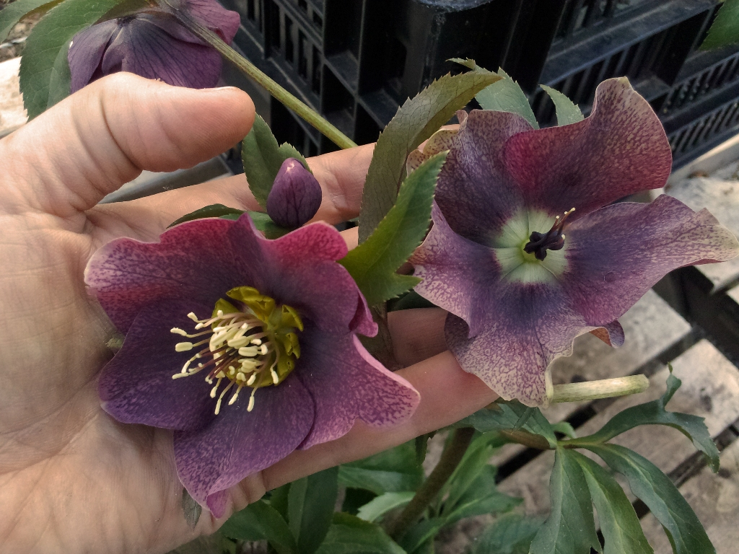

Anatomy of a Hellebore

- The ‘petals’ of a hellebore are actually sepals. The sepals surround the flower part at its center.
- The center cluster is made of finely textured stamen. Around the stamen are the petals. They are about ¼ inches tall, quite insignificant.
- The stamen and petals will drop following fertilization. Then a seed pod develops.
- As the above process takes place, the sepals change. It has been noted that the color may change during this time. The sepals also become stiff and waxy; thus, they become better candidates for floral design.

