Design Report – February 9, 2016
This coming month several S&T members are preparing individual designs to enter into the flower show. I asked them ‘How’ and ‘Why’ they chose the categories they are entering.

Philadelphia Flower Show Entries

Tala Graham – Miniature Arrangement ‘Spirit World’
Why? Well, it seems miniature arrangements are her favorite type of arrangements. You can do them ahead and just take them in. As for choosing ‘Spirit World’ as her category, she lived in Arizona for a while and she had found a small artifact in her basement that spoke to her as belonging in the ‘Spirit World’.

Any advice for the novice designer? Don’t anguish over the design, have faith in yourself as no two designers will come at the title from the same direction. Be self confident!!

Kris Qualls – Miniature Arrangement ‘Shape Shifter’
Kris has chosen a Component Challenge Class. In January PHS gave her natural objects to be used in the chosen class. Kris will take the objects apart and assemble into a design, a design that uses only those components that were given to her.

Why? Kris liked the idea that she didn’t have to think about the design until January. In this case since the materials were chosen for her, she did not have to obsess on what components would be in her design that would further the theme of a ‘Shape Shifter’.

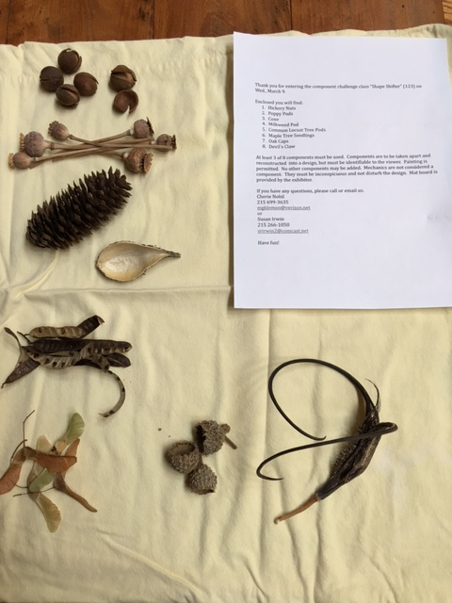

Bev Schmitt – Pedestal: Natural Beauty – Big Bend
Why? Bev likes to do pedestal designs, but she usually waits to fill in where a design is needed. This year when she first saw the categories, she signed up for the title just spoke to her.

How are you approaching your design? Deadline approaches and she thinks, ‘Oh, crap, what am I doing?’ Some people actually plan ahead--choose title, struggle with design and practice. Bev? She needs to find a container. Once container is selected, mechanics seem to fall into place. Plant materials will complete the design.

