November 2015
Designing with Gourds
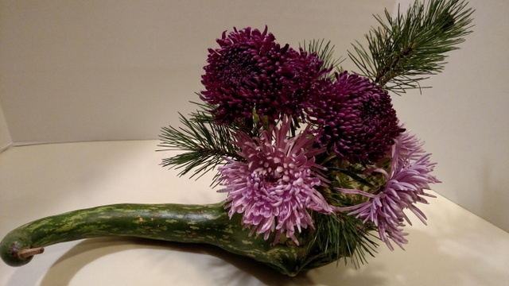

Options include:
- Using only gourds in your design
- Using gourds as an accent
- Using a gourd as your container

To make the above arrangement, a 2 ¼ inch hole was drilled. Plant materials were then added. There was no need to strip the seeds and pulp from the gourd. Plant materials will actually use the moisture and nutrients to survive. No water was added.

